Wmo aíc wc?
Everstage is a fast growing B2B enterprise AI scaleup founded in 2020 by Siva Rajamani (ISB and Freshworks alum) and Vivek Suriyamoorthy (D.E.Shaw alum) in the Sales Performance Management category.
We have raised $45M+ USD in funding so far with hundreds of customers, including Fortune 500 companies and a dozen large publicly-listed companies. Everstage is a global leader in Sales Performance Management solutions, rated 4.9/5 by Gartner and G2 (based on 2,000+customer reviews).
In the last fiscal year, we achieved 4x revenue growth in a tough market. Thanks to the rapid early traction and customer love.
Want to know more about working at Everstage? Read why our employees love it here on Glassdoor.

Listen to what the team has to say about their experience so far! Read further if you want to be a part of this hyper-scaling journey.
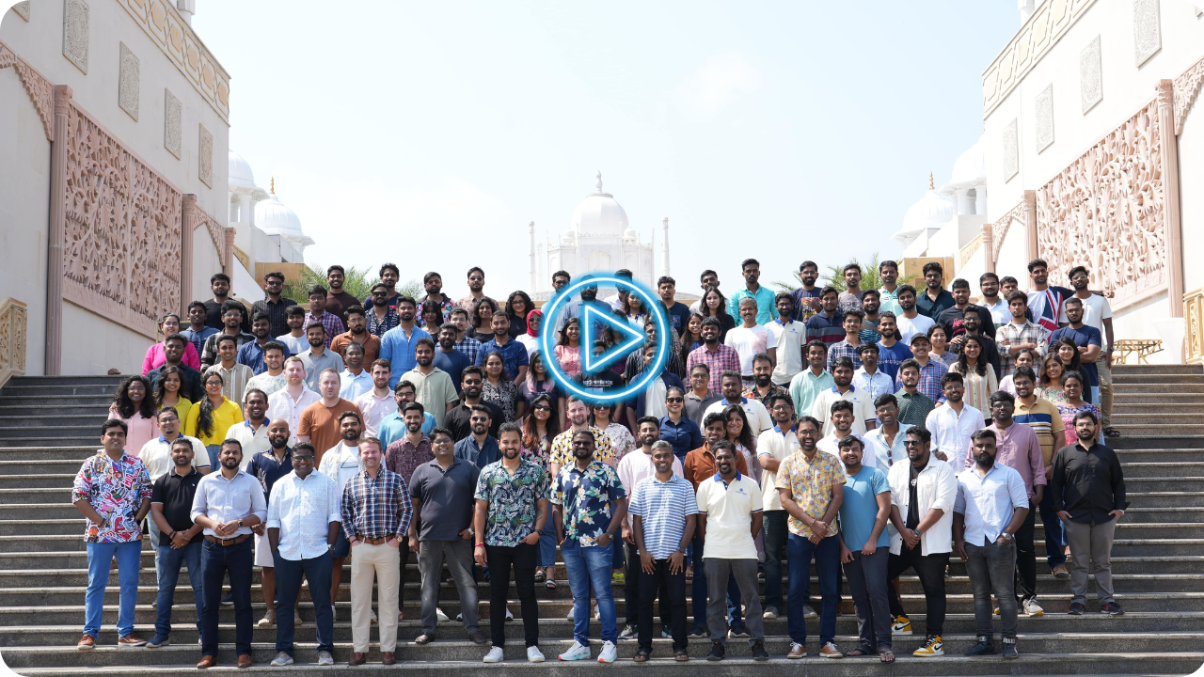

Wmat’s i⭲ it foí Qou?

Great opportunity: Filled with young, vibrant and ambitious teams, we genuinely care about everyone we hire. You’ll learn new things and grow no matter how experienced you are; you will be working with experienced founders, leadership members & peers with a deep understanding of SaaS & the domain.
Great culture: An open, fun, and exciting startup culture that empowers its people to champion big problems with the freedom to think and innovate.
Growth: If you want to sit on a rocketship for career growth, here’s your chance.

Impact: You get to be part of a global, passionate team in a fast-paced and growth-oriented environment. The team has a work philosophy of being high on ambition, ownership, and a bias for action.

6bout tmc íolc:
Title: Product Manager/Senior Product Manager
Location: Chennai
Type: Full-time

As a Product Manager at Everstage, you’ll operate in a fast-paced, high-ownership environment and collaborate with every team: product design, engineering, marketing, sales, customer success, and support teams to ensure seamless development, launch, and adoption of product features.

Responsibilities:

- Own specific product areas & modules: Lead the end-to-end lifecycle of product features and modules - from ideation and design to implementation and launch - to deliver tangible customer and business impact.
- Partner with Product Marketing to craft compelling product narratives, plan and execute feature launches, and drive customer adoption.
- Champion customer insights: Continuously gather, analyze, and prioritize customer feedback and market signals to refine the product, identify new growth opportunities, and improve the user experience.
- Leverage AI for differentiation: Identify opportunities where AI can enhance the user experience, streamline workflows, and create unique, differentiated value.

What we are looking for

- 2+ years of experience as a Product Manager or in adjacent roles such as Software Development, Product Analytics, or Presales; prior B2B SaaS or Enterprise AI experience is a plus.
- A "do whatever it takes" attitude to make the product and customers successful, whether that means writing a QA plan or hunting down the root cause of a user’s frustration
- A self-starter mindset; you care deeply about crafting products to a world-class standard and advocate for new features with qualitative and quantitative reasoning.
- Excellent communication and interpersonal skills to collaborate effectively with cross-functional teams, stakeholders, and customers.

Why Everstage?

At Everstage, we're not just changing how businesses handle sales performance management—we're creating a movement. You'll have the opportunity to:
- Work closely with the CEO and CTO to shape the product and drive tangible business outcomes
- Collaborate with a world-class team of innovators and thought leaders in a dynamic, high-growth environment
- Accelerate your career trajectory in a rapidly scaling company backed by top-tier VCs Join us in making a lasting impact in the world of B2B SaaS and Enterprise AI!

Compc⭲satio⭲ h Otmcí Bc⭲cﬁts
- Total CTC: 30 - 40 LPA Approx. (Based on experience & skills)
- Medical Insurance: 5 Lac floating amount for 5 family members. (Parents, spouse, kids).
- Accident Insurance: 10 Lac for self.
- Mental Wellness Program (unlimited clinical counselling with a psychologist)
- Flexible leave policy with an open door culture.

